Make a Hug

Are you missing family and friends? Why not send them a hug in the post?

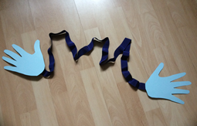

You will need:
Coloured paper
Pencil
Ribbon
Glue / Sellotape
Scissors

Instructions:
- Draw around your hands on a piece of coloured paper and cut them out.
- Find a piece of ribbon that stretches around your body.
- Attach each end of the ribbon to your paper hands.
- Now post your hug to your loved one. They will love it!

