Crystal Eggs

Make your very own Faberge Crystal Eggs

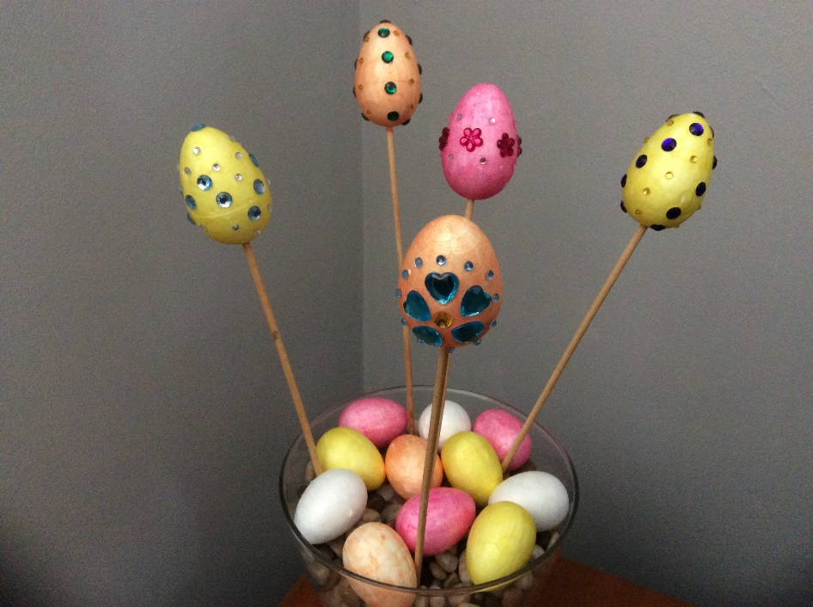

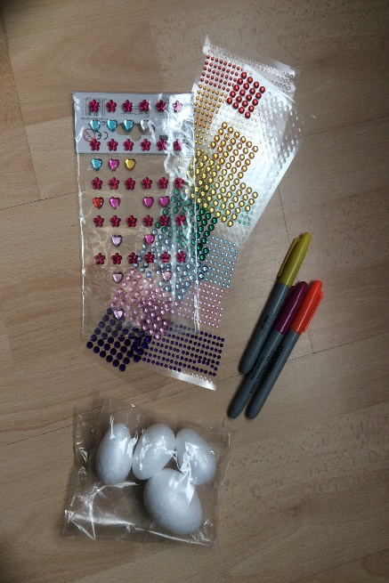

**You will need:**

Polystyrene craft eggs

Felt pens / paint

Selection of craft gems

Bamboo skewers

**Instructions:**

* Colour or paint your polystyrene eggs.
* Decorate your eggs with your favourite gems.
* Display your eggs either in a bowl or use a bamboo skewer to display in a vase.
* Why not add your eggs to a bunch of flowers.