Tissue Paper Flowers

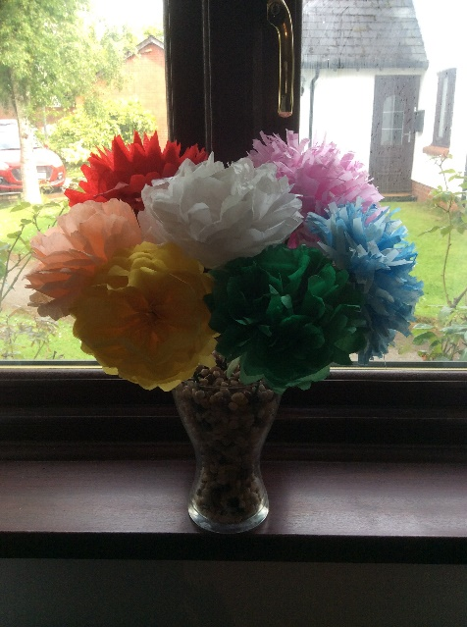

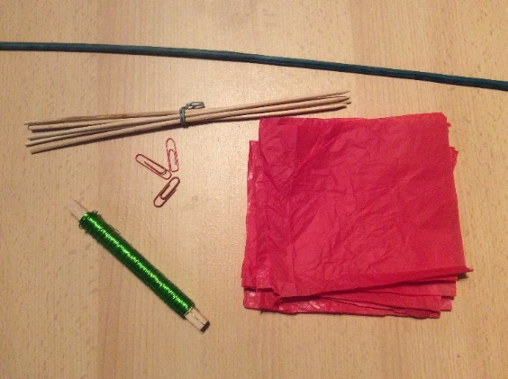

**You will need:**

Various coloured tissue paper

Craft wire or paperclips

Garden stakes or Bamboo skewers

Scissors

**Instructions:**

* Cut out 8 squares of tissue paper. I recommend about 10cms but you can cut any size. Remember the larger you cut the squares, the larger your flower will be.
* Place all of the squares on top of each other.
* Fold the tissue paper over about a centimetre, turn the squares over and fold the other way. Keep going until you have folded all of the squares. This will look like a closed paper fan.

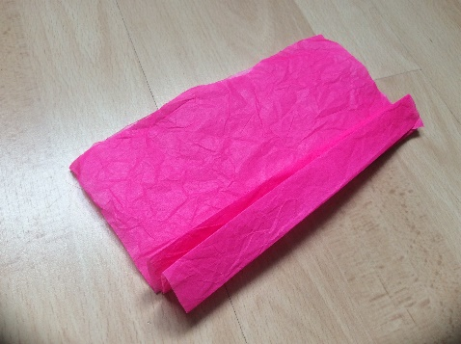

* Put some craft wire around the middle of your tissue paper fan. If you don’t have any wire a paperclip will hold the paper in place.
* Cut the ends of your tissue paper fan to make a rounded end.

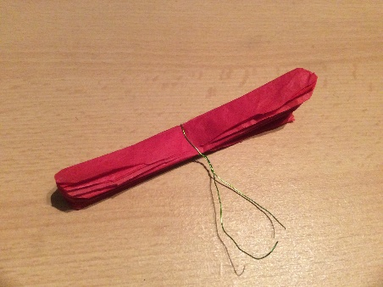 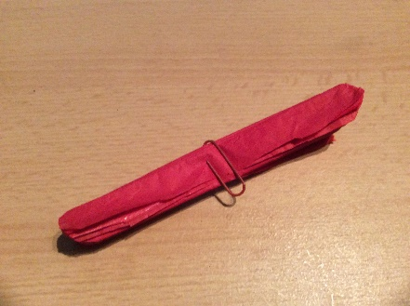

* Carefully pull apart all of the layers of tissue paper and rearrange to make your flower.

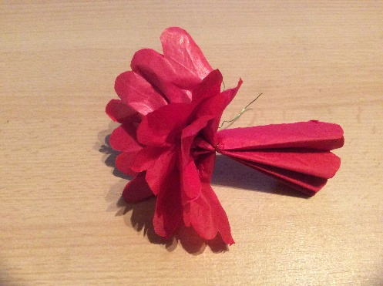

* Twist the end of the craft wire around a garden stake, and display your lower in a vase.

