Cardboard Monster

Make your own Cardboard Monster from recycled materials!

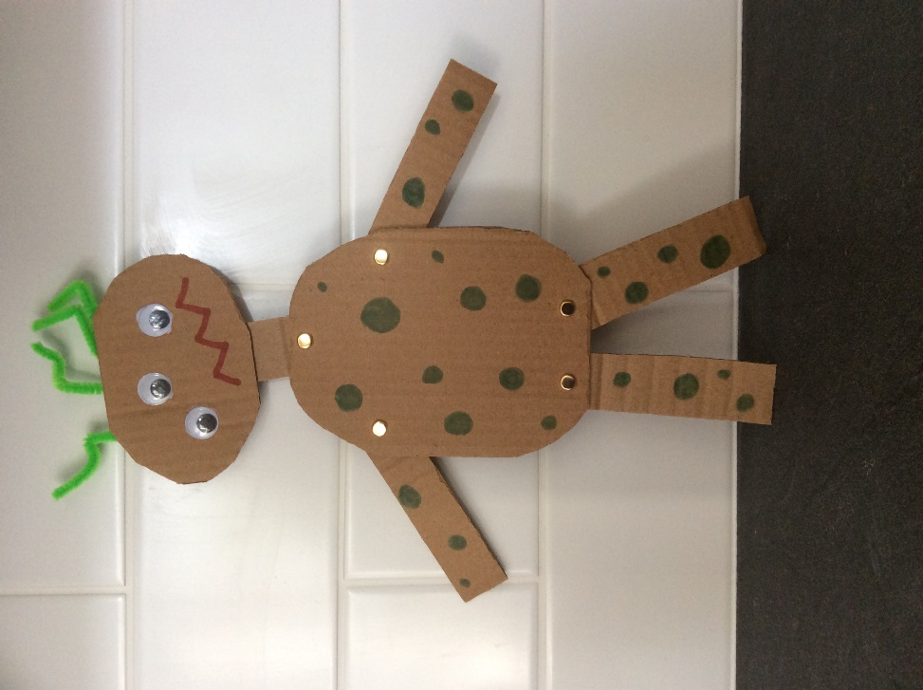

**You will need:**

Sheet of Cardboard

Split Pins

Felt Pens, Googly Eyes, stickers, paint (Decorations for your monster)

Scissors

Hole punch

**Instructions:**

* Draw on a piece of cardboard a head, a body, two arms and 2 legs separately.
* Cut out your body parts.
* Decorate with Felt Pens, Googly Eyes, stickers, paint or any combination of the above.
* Carefully use a scissors or hole punch to make holes in the end of the arms, legs, in the neck of head and in the body.
* Attach the body parts together with the split pins.