Tissue Paper Pictures

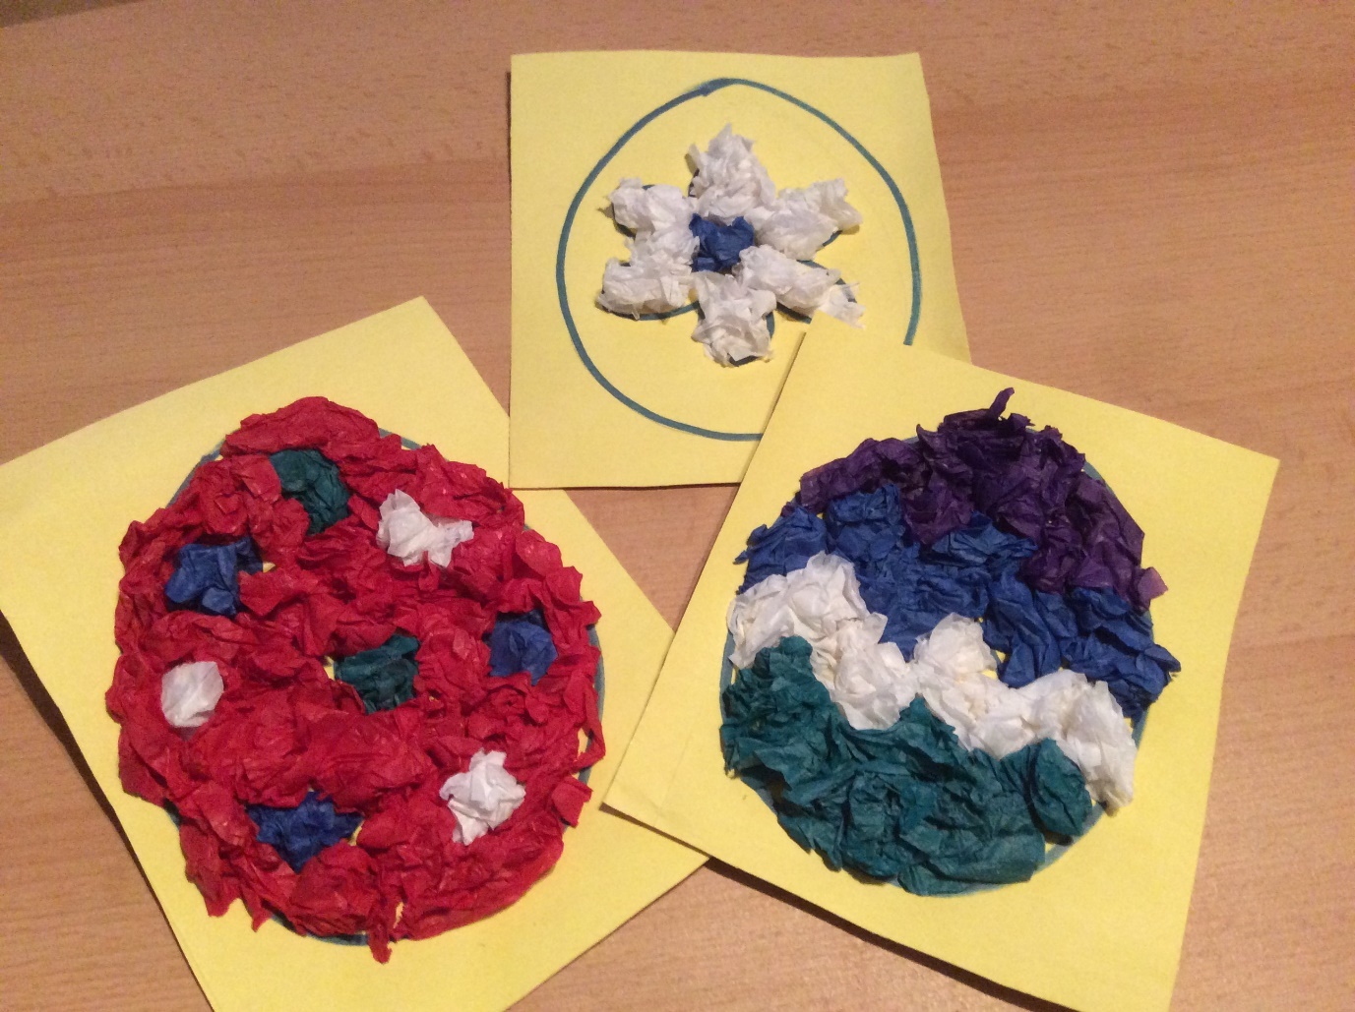

**You will need:**

Various coloured tissue paper

Paper / card

Marker pen / pencil

Scissors

Glue

**Instructions:**

* Draw the outline of your pattern on a piece of paper / card.
* Cut up lots of pieces of different coloured tissue paper and scrunch them up into small balls.
* Glue the balls of tissue paper onto your paper pattern.
* Leave to dry.