Bunch of Flowers

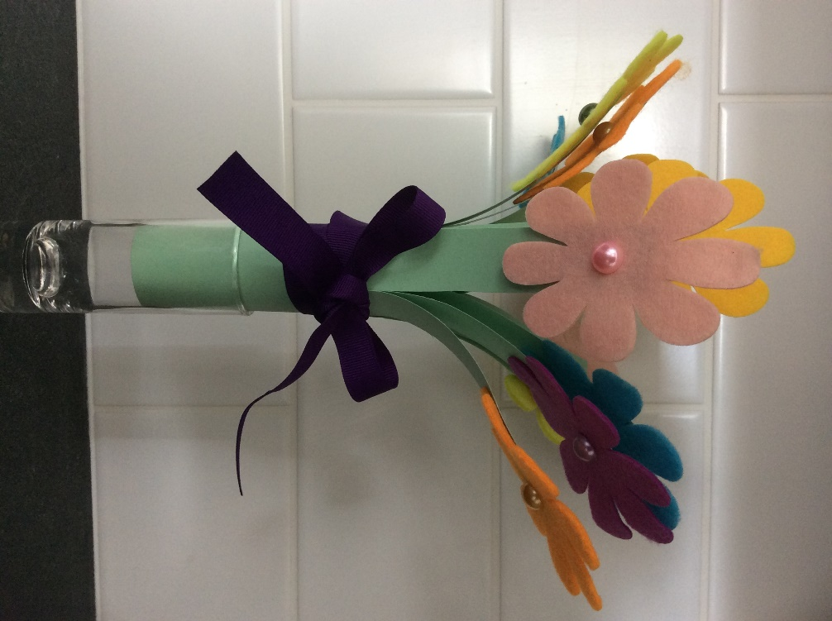

**You will need:**

Green paper

Coloured paper / felt for flowers

Crystals

PVA glue / sellotape

Ribbon

Scissors

**Instructions:**

* Cut strips about 2/3rds down the width of the paper.

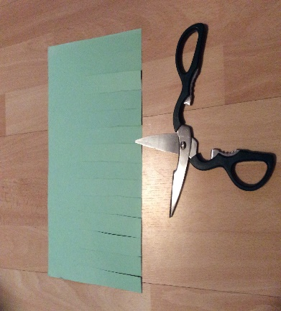

* Roll up the paper and glue / sellotape the end so that it looks like a bunch of leaves.
* Draw flowers on different coloured paper, cut these out and stick to the ends of your bunch of leaves. (If you don’t have coloured paper, use white paper and crayons or felt pens to create your own)
* Finish off your bunch of flowers with a bow made of ribbon.
* (You can also use felt or foam sheets to make your flowers)