Memory Jars

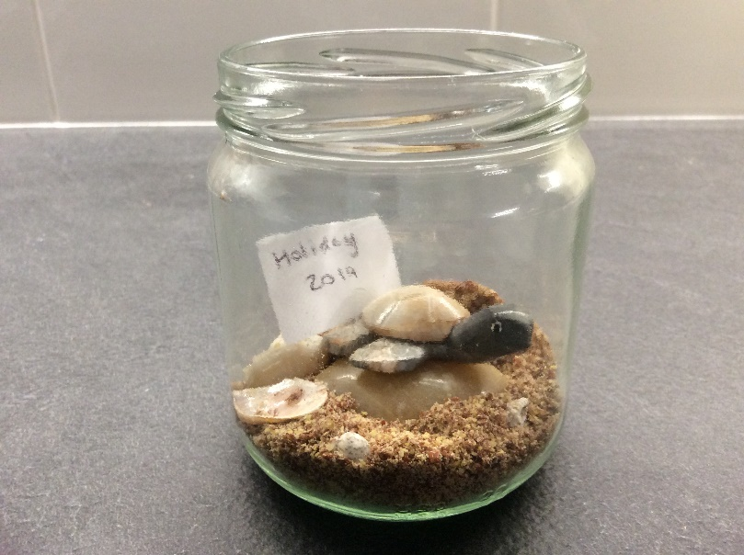

**You will need:**

Glass Jar

Sand

Shells

Pebbles

Card / Paper

Scissors

Paints / Pens

**Instructions:**

* Choose a jar and put a small amount of sand in the bottom.
* Add Shells and pebbles.
* You may want to stick seaside stickers on the outside.
* You can draw your favourite holiday memory on the outside of the jar.