Make your own Marble Maze

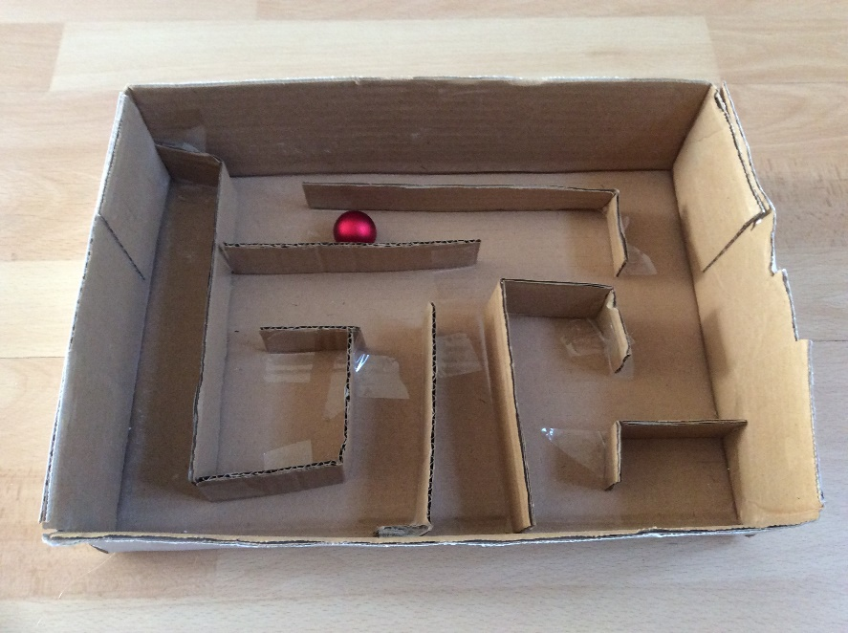

**You will need:**

Small box or box lid

PVA glue / sellotape

Various stripes of cardboard

Pencil and ruler

Scissors

Marble / Small Ball

**Instructions:**

* Cut stripes of cardboard and stick these in the box. Make sure you leave a path for the marble to get around. Leave to dry.
* Cut a hole in the side of your box, where you want the marble to exit your maze.
* Challenge your family, can they escape your maze.