Lollipop Bookmarks

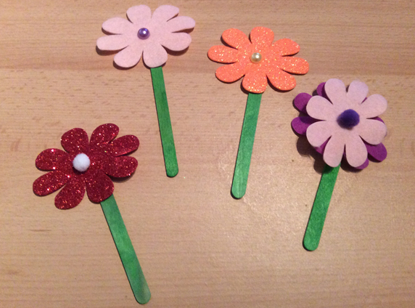 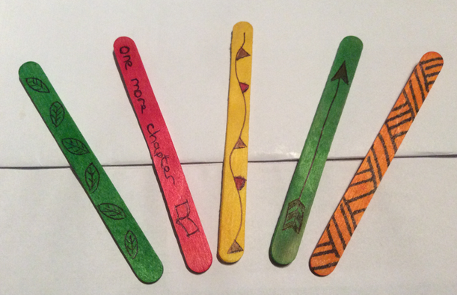

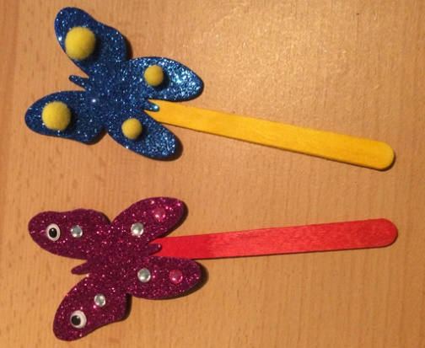 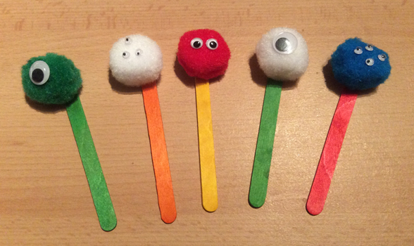 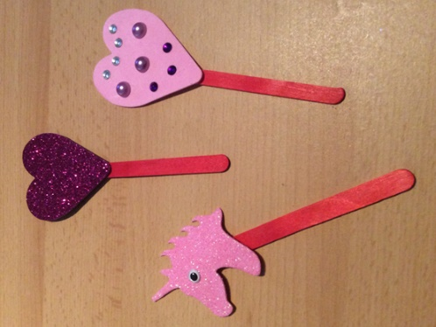

**You will need:**

Lollipop sticks

Googly Eyes

Pom poms

Crystals

Sellotape / Glue

Felt Pens

Card / Felt / Foam shapes