Lollipop Stick Pen Pot

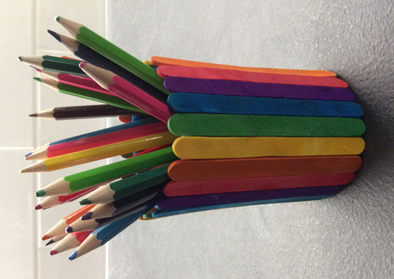

You will need:
Cardboard Tube / box
Lollipop Sticks
Paint / Felt pens
Sellotape / Glue

