CD Fish

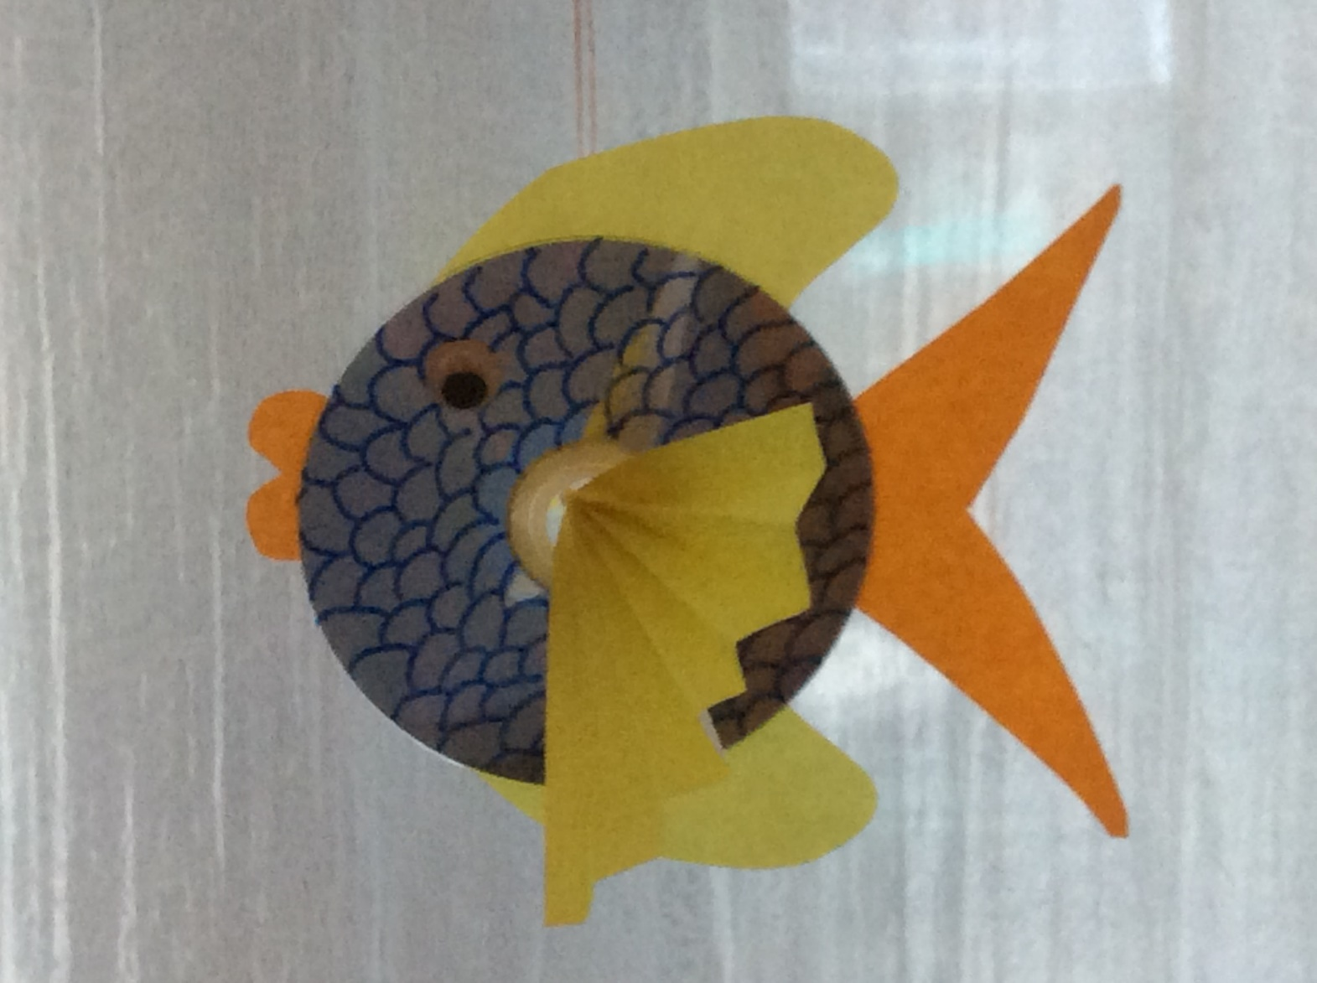

**You will need:**

Old CDs

Coloured paper

Scissors

Permanent marker

Googly eyes

Glue