Pasta Jewellery

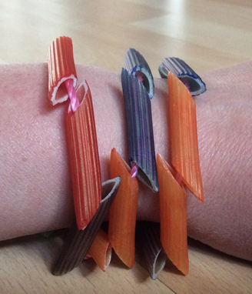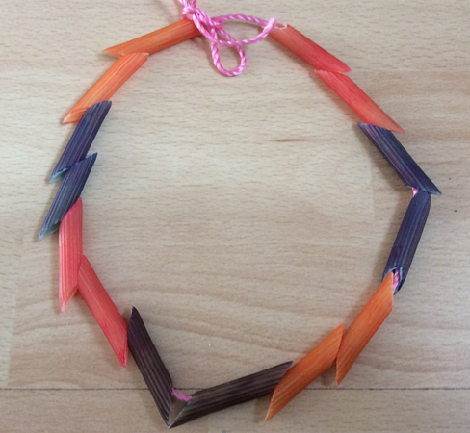

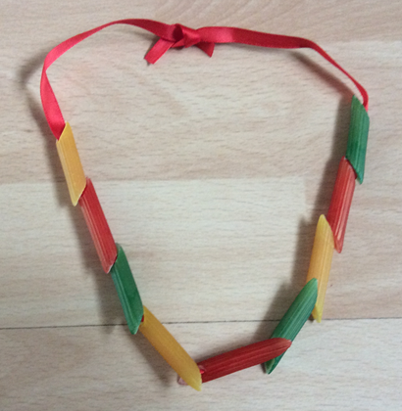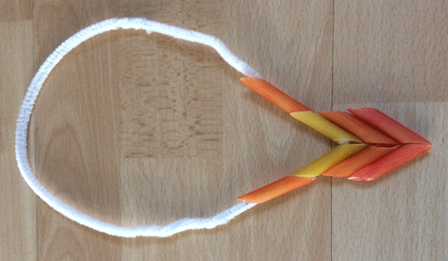
You will need:
Coloured Pasta
Beads
Ribbon / String / Wool
Elastic cord / pipecleaners
Felt Pens

Instructions:
- Choose the coloured pasta that you want to use.
- Thread the pipecleaners through the pasta and twist to hold in place.
- Decorate with ribbons and beads to make a unique jewellery piece.
- You may even want to give your jewellery a face!

