Macaroni Monsters

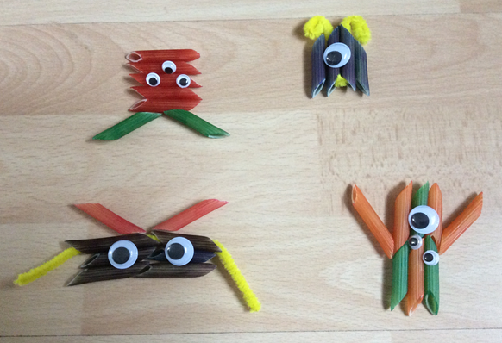

You will need:
Coloured Pasta
Beads
Googly eyes
Pipecleaners
Felt Pens / Paint
Glue

Instructions:
- Colour your pasta with felt pens or paint and wait to dry.
- Choose the coloured pasta that you want to use.
- Thread the pipecleaners through the pasta and twist to hold in place. (You may need to use some glue)
- Decorate with googly eyes to make your monster.

