Cartoon Fruit

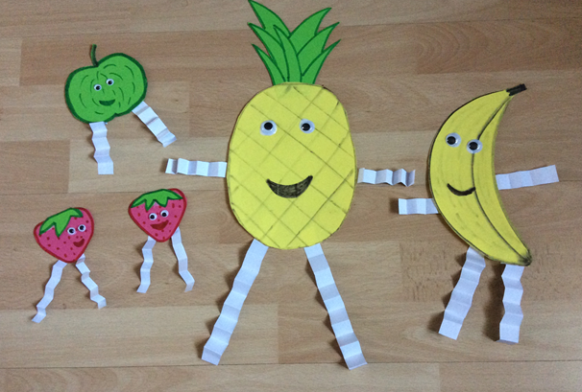

You will need:
Cardboard / Strong Paper
Pencil
Felt Pens
Googly eyes
Scissors
Sellotape / Glue

Instructions:
- Draw and colour a fruit on a piece of paper.
- Choose 4 strips of paper and fold to make a zig zag shape.
- Stick your strips onto the fruit.
- Now add a funny face to make your cartoon fruit.

