Peg Animals

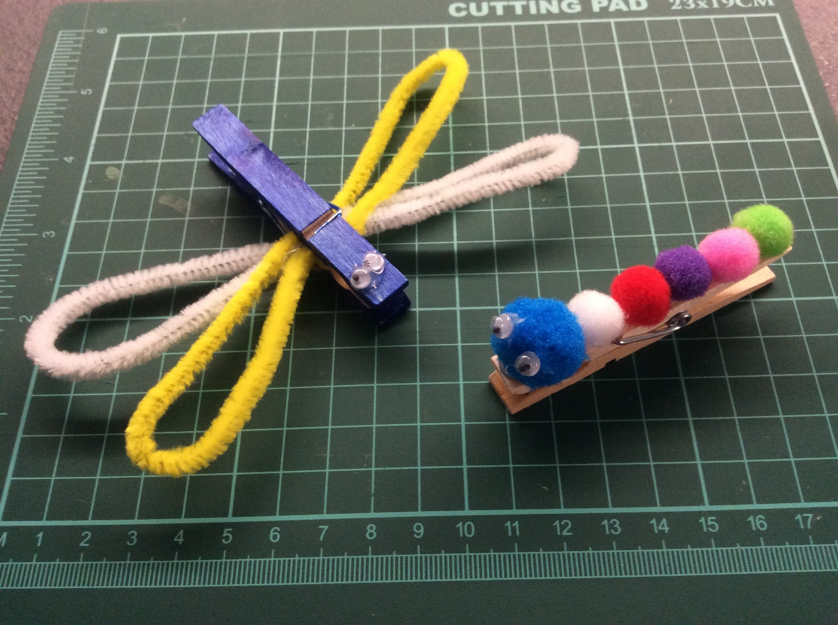

**You will need:**

Pegs

Felt Pens / Paint

Pipecleaners

Pompoms

Googly eyes

Glue