Healthy Plate

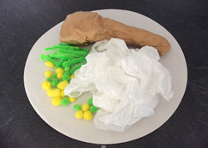

You will need:
Paper Plates
Felt Pens / Paints
Pipecleaners
Coloured paper
Wool
Cotton wool
Glue
Scissors

Instructions:
- Decide what healthy meal you would like to make and collect the resources.
- Draw, cut and stick your food onto your plate.
- Don’t forget to put lots of vegetables on your plate!

