Flower Garland

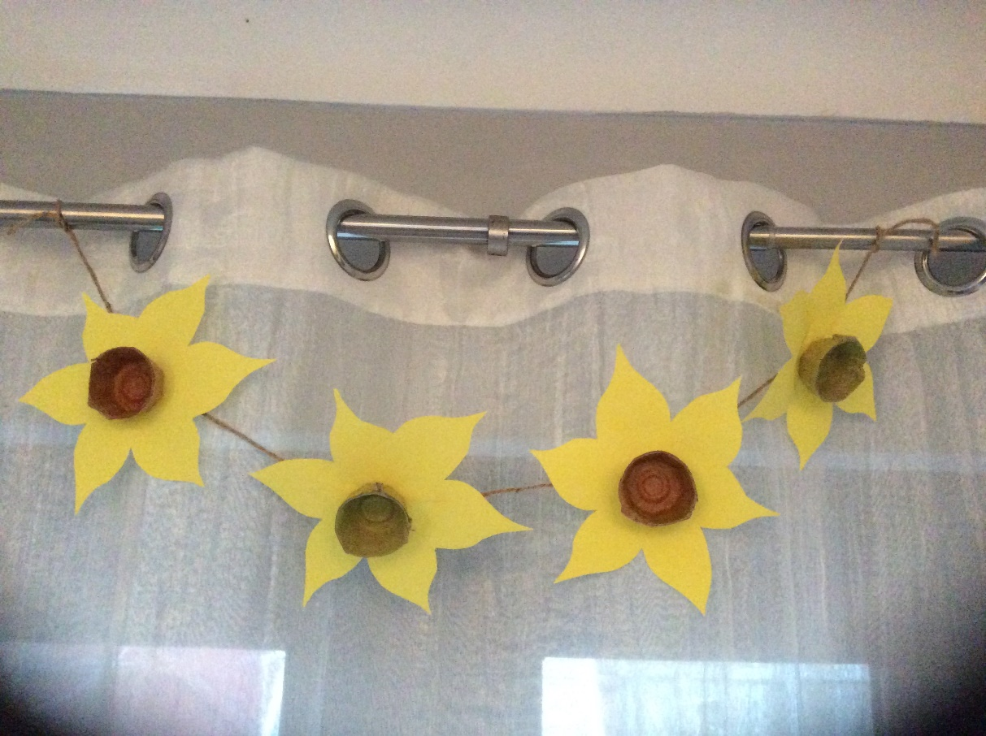

**You will need:**

Cardboard Egg Box

Coloured paper / card

Felt Pens / Paint

Scissors

Glue

String

sellotape

**Instructions:**

* Cut the egg box to make the flower centres.
* Paint / Colour each centre.
* Draw the flower shape on a piece of paper / card.
* Cut out the flower shape.
* Glue the flower centre to the flower shape.
* Sellotape the flowers along the length of the string.