Paper Strip Fruit and Vegetable

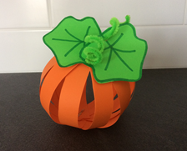

You will need:
Coloured Paper
Felt Pens
Split Pins
Pipecleaners
Scissors
Hole punch

Instructions:
- Choose the coloured paper to match your fruit / vegetable.
- Cut your paper into lots of strips (At least 12 pieces).
- Draw a leaf to match the fruit / vegetable
- Punch a hole in the top and bottom of each strip of paper, and don’t forget your leaf.
- Put all the strips of paper together.
- Push a split pin through the leaf and through all of the holes at one end of the paper strips.
- Push a split pin through the holes in the bottom of the strips and split to hold together.
- Carefully spread out the paper strips to make a round fruit / vegetable.

