**Wooden Spoon Dragon Craft**

**This wooden spoon dragon is incredibly effective and simple to make!**

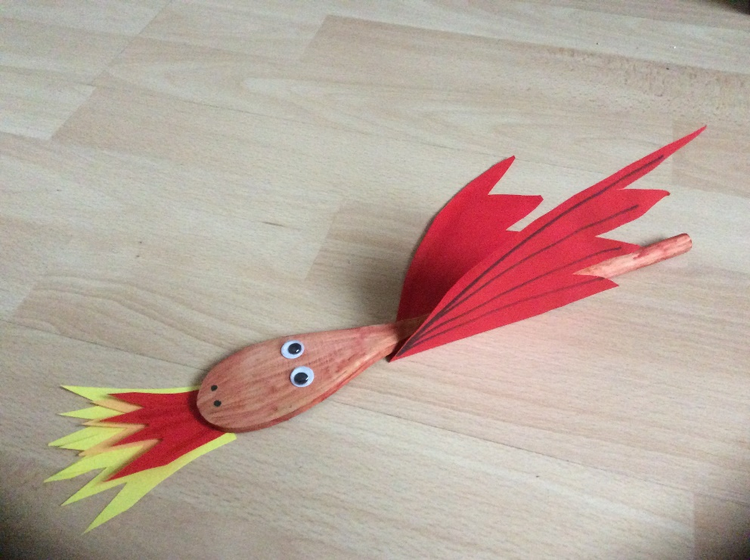

**You will need:**

**A wooden spoon  
Red paint / felt pen  
Green / Red craft foam / cardboard / paper  
Scraps of red, yellow and orange paper  
PVA glue  
Googly eyes  
Black pen**

**Instructions:**

* **Paint or colour the spoon and leave to dry.**
* **Fold the cardboard / paper in half. Draw a wing shape with the bottom along the fold. Cut around the wing shape. Unfold and decorate the wings (You may want to use some glitter)**

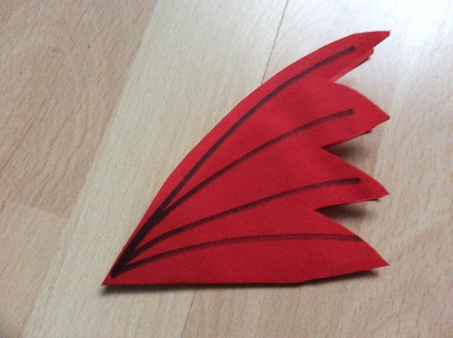 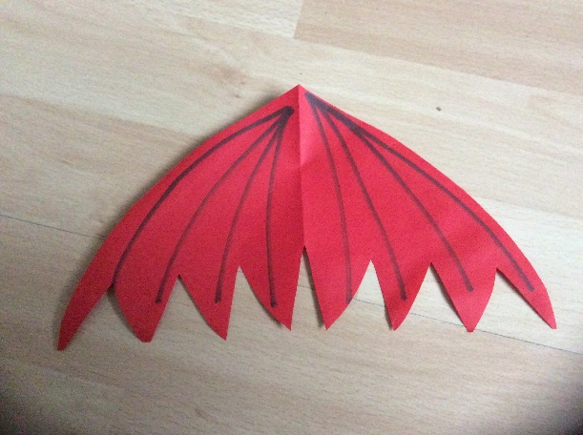

* **Glue the eyes to the back of the spoon and draw on the nose with black pen.**
* **Glue the wings to the middle part of the spoon and leave to dry.**
* **Finally cut a flame shape from yellow paper, a slightly smaller one from orange and an even smaller one from red. Glue them together in a pile and stick to the bottom of the dragons mouth.**