

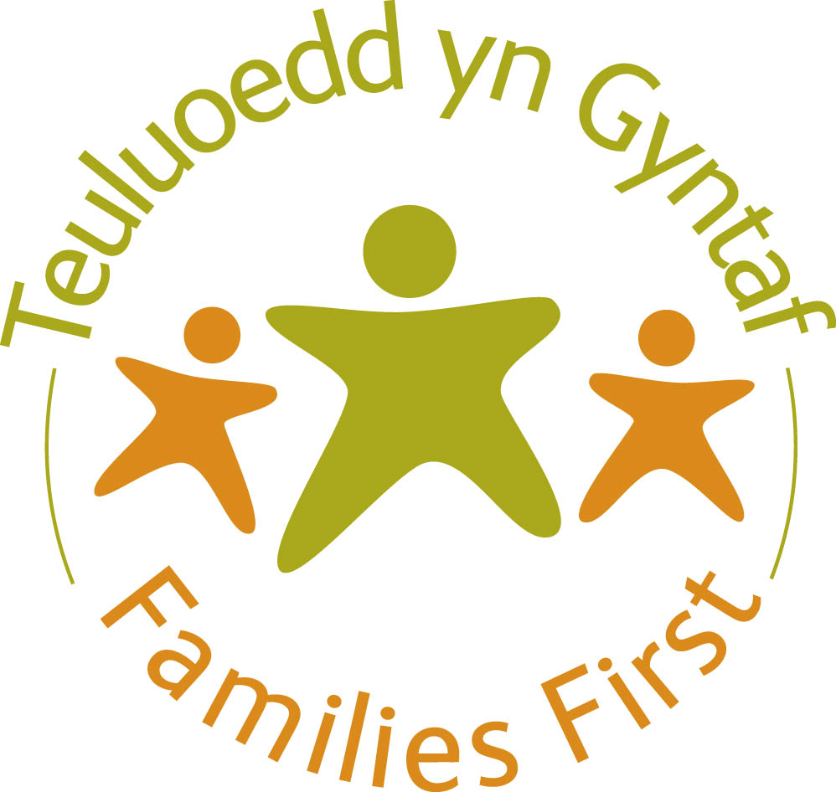


Family Wellbeing Service
REFERRAL FORM

Family Details

Parent / Carer /  Guardian  details | Name | D.O.B | Ethnicity | Address Telephone  (including  postcode)
Children’s details

Who has parental responsibility?

Who is being referred?

Date of referral

Referrer Details

Name of referrer |  | Agency/Service
Contact number |  | Email address
Address

Are you currently involved with the Family? Yes No

Household(s) Members

First name | Surname | Relationship | D.O.B | Address

Additional Needs

Does anyone referred have any disabilities? Yes No Unknown

If Yes please state

Does anyone referred have any additional needs or face any barriers to becoming involved in the project? e.g. language, literacy

Reason for referral
Please include information regarding who is being referred e.g. parent/s, child/teenager, whole family and pertinent issues

What are the desired outcomes of this referral?

Refer to appendix

Key agencies who are working with the child, young person or their family.
Agency | Contact Name | Telephone

Referrals Must fall into one of the categories below. Please refer to appendix
Family Wellbeing – refer to appendix
Additional Information:

Risk assessment: (Referrals will not be accepted if this section is not completed)

Please attach a current risk assessment

Attached No Known Risks

Please advise if there are any known risks associated with home visits e.g. violent or
dangerous individuals associated with the home, dangerous dogs, syringes etc.

P.T.O

1 | Is there any perceived risk to staff lone working? | Yes / No
2 | Is there any history of mental health issues or suicide? | Yes / No
3 | Is there any perceived risk to others? | Yes / No
4 | Are there any concerns around Child Protection? | Yes / No
5 | Are there any further concerns that you would like us to be aware of? | Yes / No

Consent

Tick to confirm referred has given consent for referral
Tick to confirm that you are willing to engage with the Family Wellbeing Service as a family

Please include written consent from referred

The information contained within this referral will be stored securely on a database by the Families First Wellbeing Service. This information is for administration purposes and your personal data will be processed by the Service in accordance with current data protection legislation. This information will be shared within the Wellbeing Service and with other Families First Partners / Agencies such as health professionals and other mainstream services to help gather further information, and to ensure that you are able to access the most appropriate support.

Please tick this box if you agree with this statement? □

Please complete and return to the Family Wellbeing Team, Connect Centre, Mendalgief Rd, Newport, NP20 2HF

Or scan and forward to: familywellbeing@newportlive.co.uk

N.B If sufficient information is not provided within the referral form, the referral may not be accepted

Parent/Guardian Signature…………………………………………………………

Child Signature (16+ years) ……………………………………………………

Referrer Signature ………………………………………………………………….

Date……………………………………………………………………………………

Appendix
Family Wellbeing Overview
The Families First Wellbeing team will provide an integrated programme to support children, young people, and their families who are living, or at risk of living, in poverty across the City; helping them to improve their health, safety, and to enjoy wellbeing.
Professional Support Offered
Newport Live Family Wellbeing Officers:
- Physical inactivity: not engaging in a form of exercise
- Social exclusion, including anti-social behaviour
- Access to community provision / support to improve self-confidence and self-esteem or to improve mental health
- Basic alcohol intervention
- Basic smoking intervention
- Healthy eating and nutritional support for families and on a 1:1 basis
- 1:1 support focusing on physical health and diversionary community sports and/or activities
- Promotion of behaviour change linked to living a healthy lifestyle
- Information, advice and sign posting to opportunities such as community groups, leisure and arts facilities, sports clubs and after school provision

