Volunteer Application Form

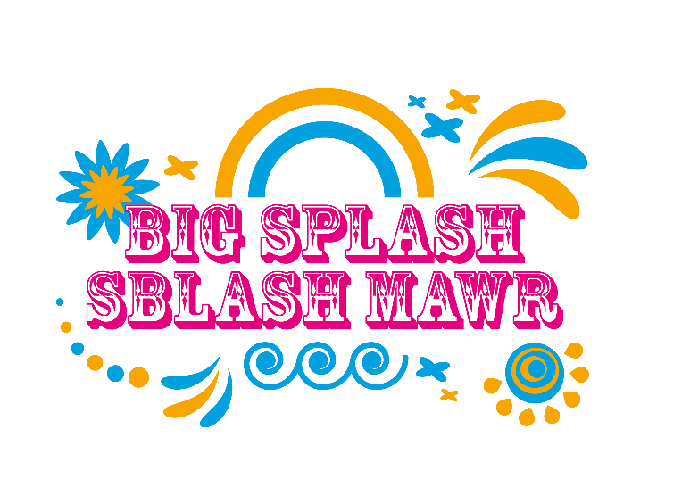
- A bit about you:
First name

Last name

Preferred Pronouns
Address Line 1

Address Line 2

Town/ city

Post code

Phone number

Email address

- Please confirm that you are over 18 years old by filling in your date of birth:
dd / mm / yyyy

- Do you have any medical conditions and/ or access requirements
 | Yes |  | No

If yes, please give more details here:
___________________________________________________________________
___________________________________________________________________
___________________________________________________________________

- Please tick all Big Splash sessions that you would be available to work.
Saturday 23 July, 10am – 2pm
Saturday 23 July, 2pm - 6pm
Sunday 24 July, 10am – 2pm
Sunday 24 July, 2pm - 6pm

- Please tick all languages in which you can communicate confidently, and which you would be willing to use with members of the public during Big Splash.
 | English |  | Welsh
 | British Sign Language |  | Other (please specify)  ________________________

- Do you have any other relevant skills that you would like to make us aware of?
_________________________________________________________________________ _________________________________________________________________________
_________________________________________________________________________
All volunteers will be given a t-shirt to wear over the Big Splash weekend. Please specify your preferred size.
Small |  | Medium |  | Large |  | X-Large |  | XX-Large

- Please leave your emergency contact details.
First name

Last name
Relationship to you (eg. mother, husband)

Home phone number

Mobile phone
number

Please return this form by email at The Riverfront Box Office by 18 June to riverfront.boxoffice@newportlive.co.uk

Equal opportunities monitoring form
We are committed to having a workforce that promotes equality and celebrates diversity. To help us monitor and achieve this, we gather and use information about job and volunteer applicants and our workforce to continually improve our policies and to remove barriers to and within employment. The information you give is confidentially managed and does not affect your application.
It will help us if you provide as much information as possible, but if you do not wish to answer any questions, please leave them blank.
What age group are you (years)?
Up to 20 |  | 36-40 |  | 56-60
20-25 |  | 41-45 |  | 61-65
26-30 |  | 46-50 |  | 66 +
31-35 |  | 51-55

What gender do you identify as?
Male |  | Female
Non-Binary |  | Other preferred description

How do you describe your religion or belief (if any)?
Buddhism |  | Judaism
Christianity |  | Sikhism
Hinduism |  | Other (please specify):
Islam

Do you consider yourself to have a disability?
 | Yes |  | No

How do you describe your ethnic origin?
Please select the ethnic group that you feel most closely reflects your background.
White
British |  | English |  | Scottish
Welsh |  | Irish |  | Other white background (please specify):  ___________________________________
Mixed
White & Asian |  | White & Black Caribbean
White & Black African |  | Other mixed background (please specify):  ___________________________________
Black or Black British
African |  | Caribbean |  | Other black background (please specify):  ___________________________________

Asian
Bangladeshi |  | Pakistani
Indian |  | Other Asian background (please specify):  ___________________________________

Chinese and Other ethnic group
Chinese |  | Gypsy, Roma, traveller
Other ethnic background (please specify):
___________________________________

