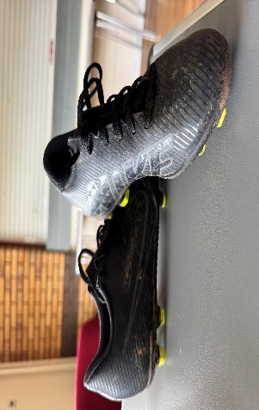
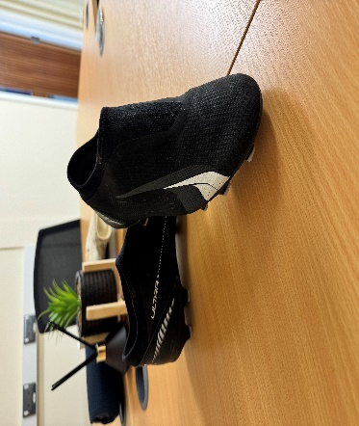
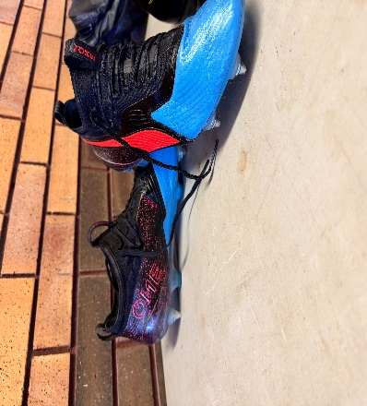
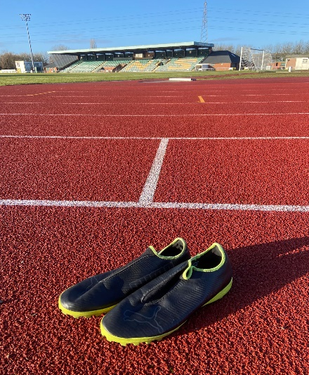
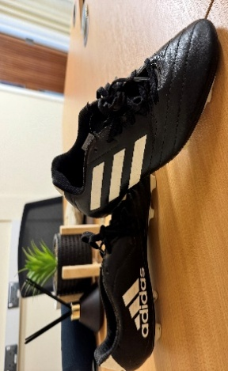
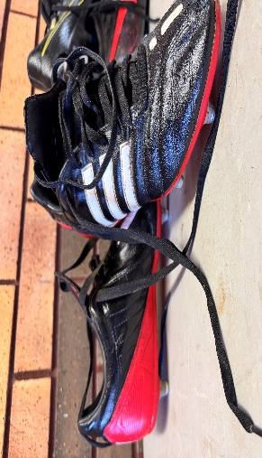
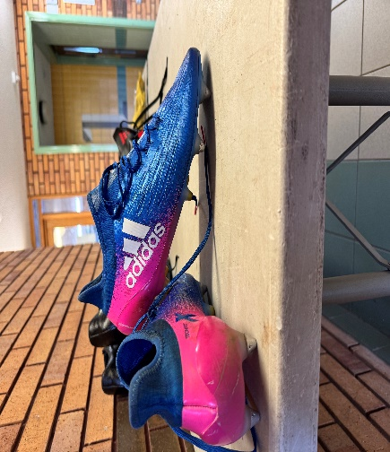
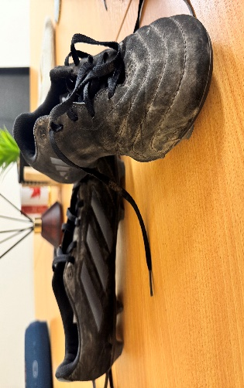
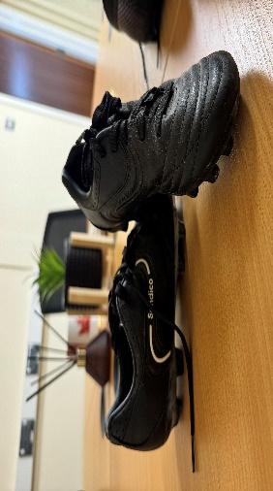
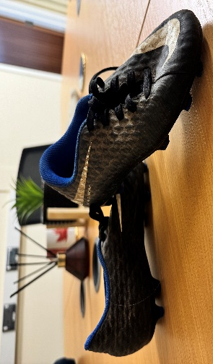
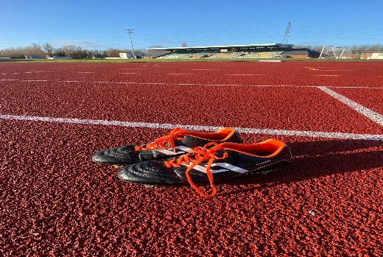
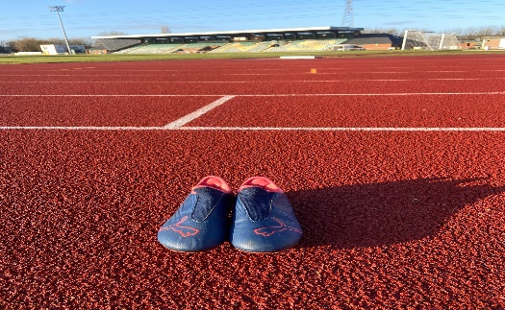
Puma astro turf/indoor, Black & Yellow.
Size: Adult’s 12 Condition: Very Good
Nike, Black
Size: 2 Condition: Very Good
Adidas, Black, white & Red
Size: 10.5 Condition: Very Good
Puma, Blue, Black, Red
Size: 10 Condition: Very Good
Adidas, Blue & Pink
Size: 10 Condition: Very Good
Nike, Black.
Size: Child’s 12 Condition: Very Good
Sondico, Black
Size: Child’s 12 Condition: Very Good
Adidas: Black
Size: 7.5 Condition: Good
Puma, Black & White
Size: 5 Condition: Very Good
Rugby Boots: Black, white, orange.
Size: 6 Condition: Very Good
Puma, Blue & Red
Size: 4 Condition: Very Good
Adidas, Black & White
Size: 5.5 Condition: Very Good

