Recycled decorations

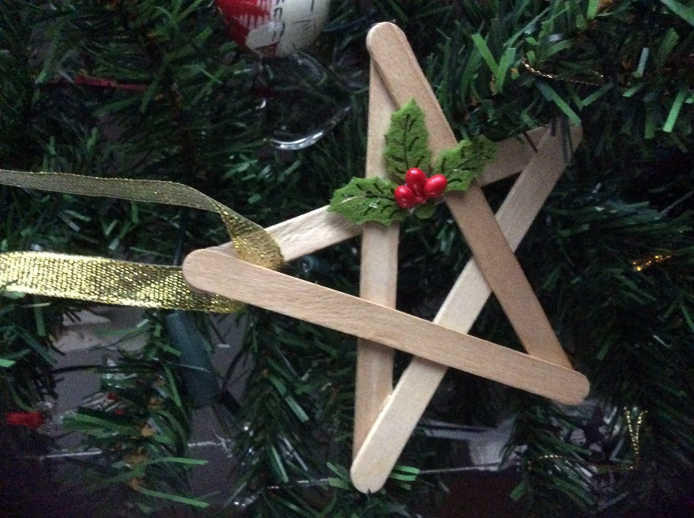

**You will need:**

Lolly Sticks

Glue

Ribbon

Decorations

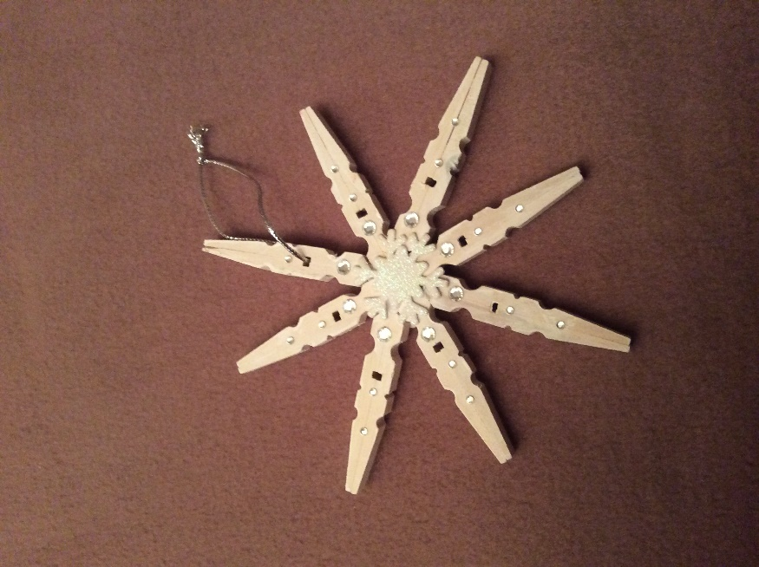

**You will need:**

Wooden clothes pegs

Glue

Ribbon

Decorations